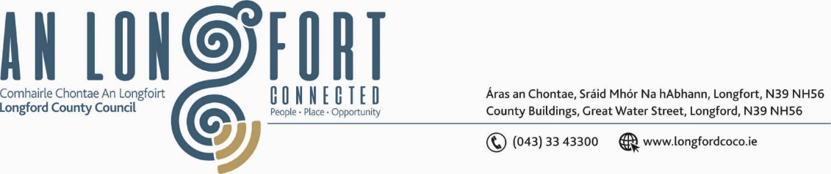

***LONGFORD MUNICIPAL DISTRICT***

***Please note meeting will be held via Microsoft Teams.***

**18th March 2021.**

**To: Each Member of Longford Municipal District.**

**Dear Member,**

You are requested to attend Meeting of Longford Municipal District to be held

**via Microsoft Teams** on **Wednesday, 24thMarch 2021 at 4.30 p.m.** to transact business, as set out on the Agenda hereunder.

**Yours sincerely**,

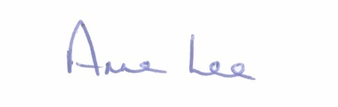

_______________

**Anne Lee,**

**Meetings Administrator.**

**AGENDA**

Prayer before meeting.

**1.** Confirmation of Minutes of Longford Municipal District  Meeting held on the 24th February 2021 – copy enclosed.

**2.** Matters arising from Minutes.

**3.** Declaration of Interest by Members.

**4.** Management Report - enclosed.

**5.** Consideration of applications for funding under the 2021 Community Grant

Support Scheme - list enclosed.

**6.** Consideration of 2021 Schedule of Longford Municipal District Works –

enclosed

1. Consideration of Adoption of Part 8 No. 83 in accordance with Section 179 of

the Planning and Development Act 2000 (as amended) and Part 8 of the Planning

and Development Regulations 2001 in respect of the construction of a Greenway

at Newtownforbes, Co Longford -  details enclosed.

**7. Notices of Motions, submitted by Councillors, as listed hereunder –**

**Councillor Uruemu Adejinmi**

“It was brought to my attention that high use-buttons on pay parking meters in the town can increase the spread of infection and there’s no sanitising facility close by so machines can be sanitised after each use. In addition, they lacked flexibility in available payment methods, being restricted to coin payments only and people often get caught short for change for pay parking meters whilst parking in the towns.

I am calling on the Council to implement pay parking meters with contactless payment options, credit card payment facilities as well as the option through a pay parking app.”  
  
**Councillor Gerry Hagan**

1. “I call on Longford MD to Install a footpath along the Knockloughlin road to Kiernan’s Cross. There is a large number of houses in this area and with the current restrictions there is a lot of people using this road for walking and exercising, which is hazardous with the large volume of traffic using this road. Located here also is Brookfield house with special needs people who go out walking everyday with staff”.

1. “I call on Longford MD to fill in the drain on the Kelleter Road towards the Aughagar Cross end. This is a narrow road with substantial traffic and the open drains on both sides of the road present a very significant health and safety hazard, for pedestrians and motorists”.

**Councillor Martin Monaghan**

1. “That Longford County Council look at the removal of the bad bend on the L-1005 at the junction of Lamagh and Curryline, Newtownforbes. The junction is extremely hazardous to vehicles and pedestrians (mostly School Kids) as it is a blind corner whatever way you approach it. There is a school within 300 meters of this point along with a substantial volume of commercial vehicles presenting to the nearby DOE Centre and a very busy Physio’s practice on this stretch of road along with 2 sporting clubs”.
2. “That Longford County Council look at implementing speed restrictions in the Farneyhoogan estate. This area is now populated with young families and young children, the apparent danger of vehicles has now become a major issue and I urge that we look at this issue as a matter of urgency”.
3. “That Longford County Council look at installing raised platforms or similar to reduce speed in the village of Clondra”.

**Councillor Seamus Butler**

1. “That Longford Municipal District allows the issuing of all-day season ticket parking in the back carpark (off St Mel’s Road) at the Longford Shopping Centre”.
2. “That Longford Municipal District draws up an imaginative, ready to go plan in anticipation of the opening of non-essential retail, including parking charge concessions and advertising outdoor dining among other measures. Marketing the plan, with widespread publicity, will be crucial to create increased footfall and the successful reinvigoration of our town post Covid-19. The message should be **Longford is Back in Business”.**

**Councillor John Browne**

“I call on Longford County Council to have new footpaths put in place in Earl Street and in particular at the railway station end. Compensation claims may arise from falls, due to the current state of the footpaths”